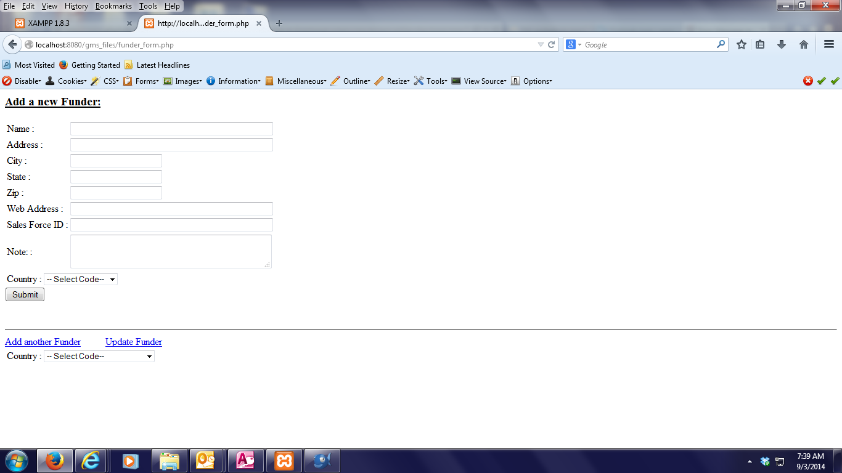
Data is not showing.
Data is showing.

function printform(){
//$PageTitle='Print - Name of the Title';
//include("hd.php");
print <<< HERE
<h3><u> Add a new Funder:</u></h3>
<form id="myform" method ="POST">

<TABLE>
<tr>
<td>Name :</td>
<td><input type="text" name="F_Name" size="50" maxlength="250"></td>
</tr>

<tr>
<td>Address : </td>
<td><input type="text" name="F_Add" size="50" maxlength="250"></td>
</tr>
<tr>
<td>City : </td>
<td><input type="text" name="F_City" size="20" maxlength="50"></td>
</tr>
<tr>
<td>State : </td>
<td><input type="text" name="F_State" size="20" maxlength="50"></td>
</tr>
<tr>
<td>Zip : </td>
<td><input type="text" name="F_Zip" size="20" maxlength="10"></td>
</tr>
<tr>
<td>Web Address : </td>
<td><input type="text" name="F_Web" size="50" maxlength="200"></td>
</tr>
<tr>
<td>Sales Force ID : </td>
<td><input type="text" name="F_Sf" size="50" maxlength="20"></td>
</tr>
<tr>
<td>Note: : </td>
<td>
<textarea rows="2" cols="38" type="text" name="F_Note" width="50"> </textarea>
</td>
</tr>

</TABLE>

<!--- End --------------->

<html>
<TABLE>
<tr>
<td>Country :</td>
<td><label>
<select name="select" class="textfields" id="ddlcountry">
<option id="0">-- Select Code-- </option>

<?php
include("gms_cn.php");
$query = "select * from type order by types";
$result = mysql_query($query);

while ($row = mysql_fetch_array($result)){
?>

<option id="<?php echo {$row['type_id']}; ?>">
<?php echo {$row['types']}; ?></option>

<?php } ?>

<?php mysql_free_result($result);?>

</select>
</label></td>
</tr>

</TABLE>

<html>

<div id="mySubmit">
<input type="submit" name="Submit" value ="Submit">
</div>

</form>

HERE;

}

