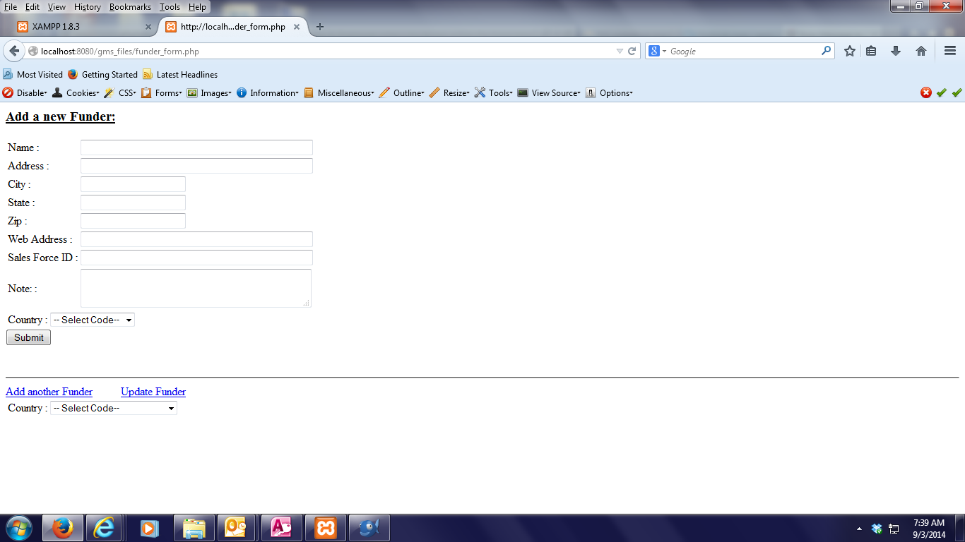
Data is not showing.
Data is showing.

function addData(){

$Name=cleanData($_POST['F_Name']);
$Add=cleanData($_POST['F_Add']);
$City=cleanData($_POST['F_City']);
$State=cleanData($_POST['F_State']);
$Zip=cleanData($_POST['F_Zip']);
$Web=cleanData($_POST['F_Web']);
$Sf=cleanData($_POST['F_Sf']);
$Note=cleanData($_POST['F_Note']);
$mgr=2;
$type="manual entry";

//print "Ready to add data";
//include ("cn.php");
print $Name;
$sql="insert into funders (funder_id,
fundername,
funder_address,
funder_city,
funder_state,
funder_zip,
website,
sfid,
funder_note,
manager_id,
funder_type
)
values(null,
'$Name',
'$Add',
'$City',
'$State',
'$Zip',
'$Web',
'$Sf',
'$Note',
'$mgr',
'$type'

)";
//$result= mysql_query($sql) or die (mysql_error());
if (empty($Name)) {
} else {
if (mysql_query($sql)) {
echo "New funder has been added in the database.<br /><br />";
}
}

print <<< HERE
<h2> The following has been added: </h2>
<ul>
<li>Manager Name: $Name </li>
</ul>
HERE;

//-----------------------
//echo "<br /><hr /><br />";

}

function printform(){
//$PageTitle='Print - Name of the Title';
//include("hd.php");
print <<< HERE
<h3><u> Add a new Funder:</u></h3>
<form id="myform" method ="POST">

<TABLE>
<tr>
<td>Name :</td>
<td><input type="text" name="F_Name" size="50" maxlength="250"></td>
</tr>

<tr>
<td>Address : </td>
<td><input type="text" name="F_Add" size="50" maxlength="250"></td>
</tr>
<tr>
<td>City : </td>
<td><input type="text" name="F_City" size="20" maxlength="50"></td>
</tr>
<tr>
<td>State : </td>
<td><input type="text" name="F_State" size="20" maxlength="50"></td>
</tr>
<tr>
<td>Zip : </td>
<td><input type="text" name="F_Zip" size="20" maxlength="10"></td>
</tr>
<tr>
<td>Web Address : </td>
<td><input type="text" name="F_Web" size="50" maxlength="200"></td>
</tr>
<tr>
<td>Sales Force ID : </td>
<td><input type="text" name="F_Sf" size="50" maxlength="20"></td>
</tr>
<tr>
<td>Note: : </td>
<td>
<textarea rows="2" cols="38" type="text" name="F_Note" width="50"> </textarea>
</td>
</tr>

</TABLE>

<!--- End --------------->

<html>
<TABLE>
<tr>
<td>Country :</td>
<td><label>
<select name="select" class="textfields" id="ddlcountry">
<option id="0">-- Select Code-- </option>

<?php
include("gms_cn.php");
$query = "select * from type order by types";
$result = mysql_query($query);

while ($row = mysql_fetch_array($result)){
?>

<option id="<?php echo {$row['type_id']}; ?>">
<?php echo {$row['types']}; ?></option>

<?php } ?>

<?php mysql_free_result($result);?>

</select>
</label></td>
</tr>

</TABLE>

<html>

<div id="mySubmit">
<input type="submit" name="Submit" value ="Submit">
</div>

</form>

HERE;

}

